**Assignment 4: Becoming an Independent Data Scientist**

1. Region & Domain

State the region and the domain category that your data sets are about.

Union Territories, India Economic Activity or Measures

# Research Question

You must state a question about the domain category and region that you identified as being interesting.

What is the impact of being lived in Indian sates or Union territories on the average unemployment rate in?

The period between 2016 and June 2017?

# Links

You must provide at least two links to publicly accessible datasets. These could be links to les such as CSV or Excel files, or links to websites which might have data in tabular form, such as Wikipedia pages.

* + <https://unemploymentinindia.cmie.com/kommon/bin/sr.php?kall=wtabnav&tab=4020>
  + <https://tradingeconomics.com/india/unemployment-rate>

# Visualization

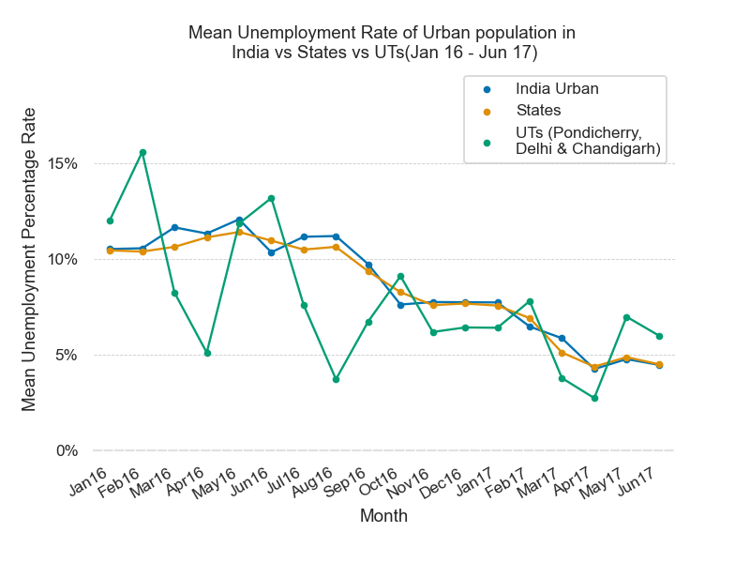You must upload an image which addresses the research question you stated. In addition to addressing the question, this visual should follow Cairo's principles of truthfulness, functionality, beauty, and insightfulness.

# Discussion

You must contribute a short (1-2 paragraph) written justification of how your visualization addresses your stated research question.

This visualization was concerned with answering the question of how the unemployment rate of Union Territories of India have changed against Indian States and India Overall over the past one and half year for Urban population. The data was collected from CMIE website. CMIE stands for Centre for Monitoring Indian Economy that conducts monthly and weekly surveys over 160,000+ households. Mean employment rates for states and union territories were calculated to help the reader identify any major trends and variations from it.

The Unemployment rate witnesses a decreasing trend over the past 1.5 years from as high as 10.5% in Jan 2016 to 4.5% in Jun 2017. The Union Territories seem to have a very volatile unemployment rate movement by virtue of their population compared to rest of the regions. In the months of February this rate increases each year and similarly in the month of May. The month of April usually has low unemployment rates in Union Territories.

# Discussion

As this assignment is for the whole course, you must incorporate and defend the principles discussed in the first

week, specifically, Cairo’s principles of truth, beauty, function, and insight. For each of the following prompts, please provide a response that links each principle to one or more elements of your visual.

* + Truthfulness: The UTs label has been edited to show that only 3 UTs are shown while the present number of UTs is 7.
  + Beauty: The colorblind palette has been used to aid colorblind readers to read the visualization
  + Functionality: Data ink ratio was reduced by removing the frames
  + Insightfulness: This has been shown in by marking highly volatile UTs in Green and states and India Urban in Orange and blue respectively.

# important orientation.

**Union Territories in India**

* India has a total of 8 Union Territories and 28 states. The 8 Union territories in India include Delhi, Jammu & Kashmir, Ladakh, Dadra and Nagar Haveli and Daman and Diu, Puducherry, Chandigarh, Andaman and Nicobar Islands and Lakshadweep. Union Territory is a special administrative sector in the Republic of India. Unlike the states of India which have their own state governments, they do not have a government of their own and are controlled by central government (union government). Out of the nine union territories of India, Delhi, Puducherry (formerly Pondicherry) and J & K have their own legislatures. Each union territory has a capital of its own or the main area of administration.

source: <https://www.holidify.com/collections/union-territories-of-india>